CV

::::,

C:

CV

>

c(

CV

co

"'C

C:

CV

c(
West Valley College I 14000 Fruitvale Ave, Saratoga, California 95070
Parking is FREE for car show attendees in parking LOT #5 only.

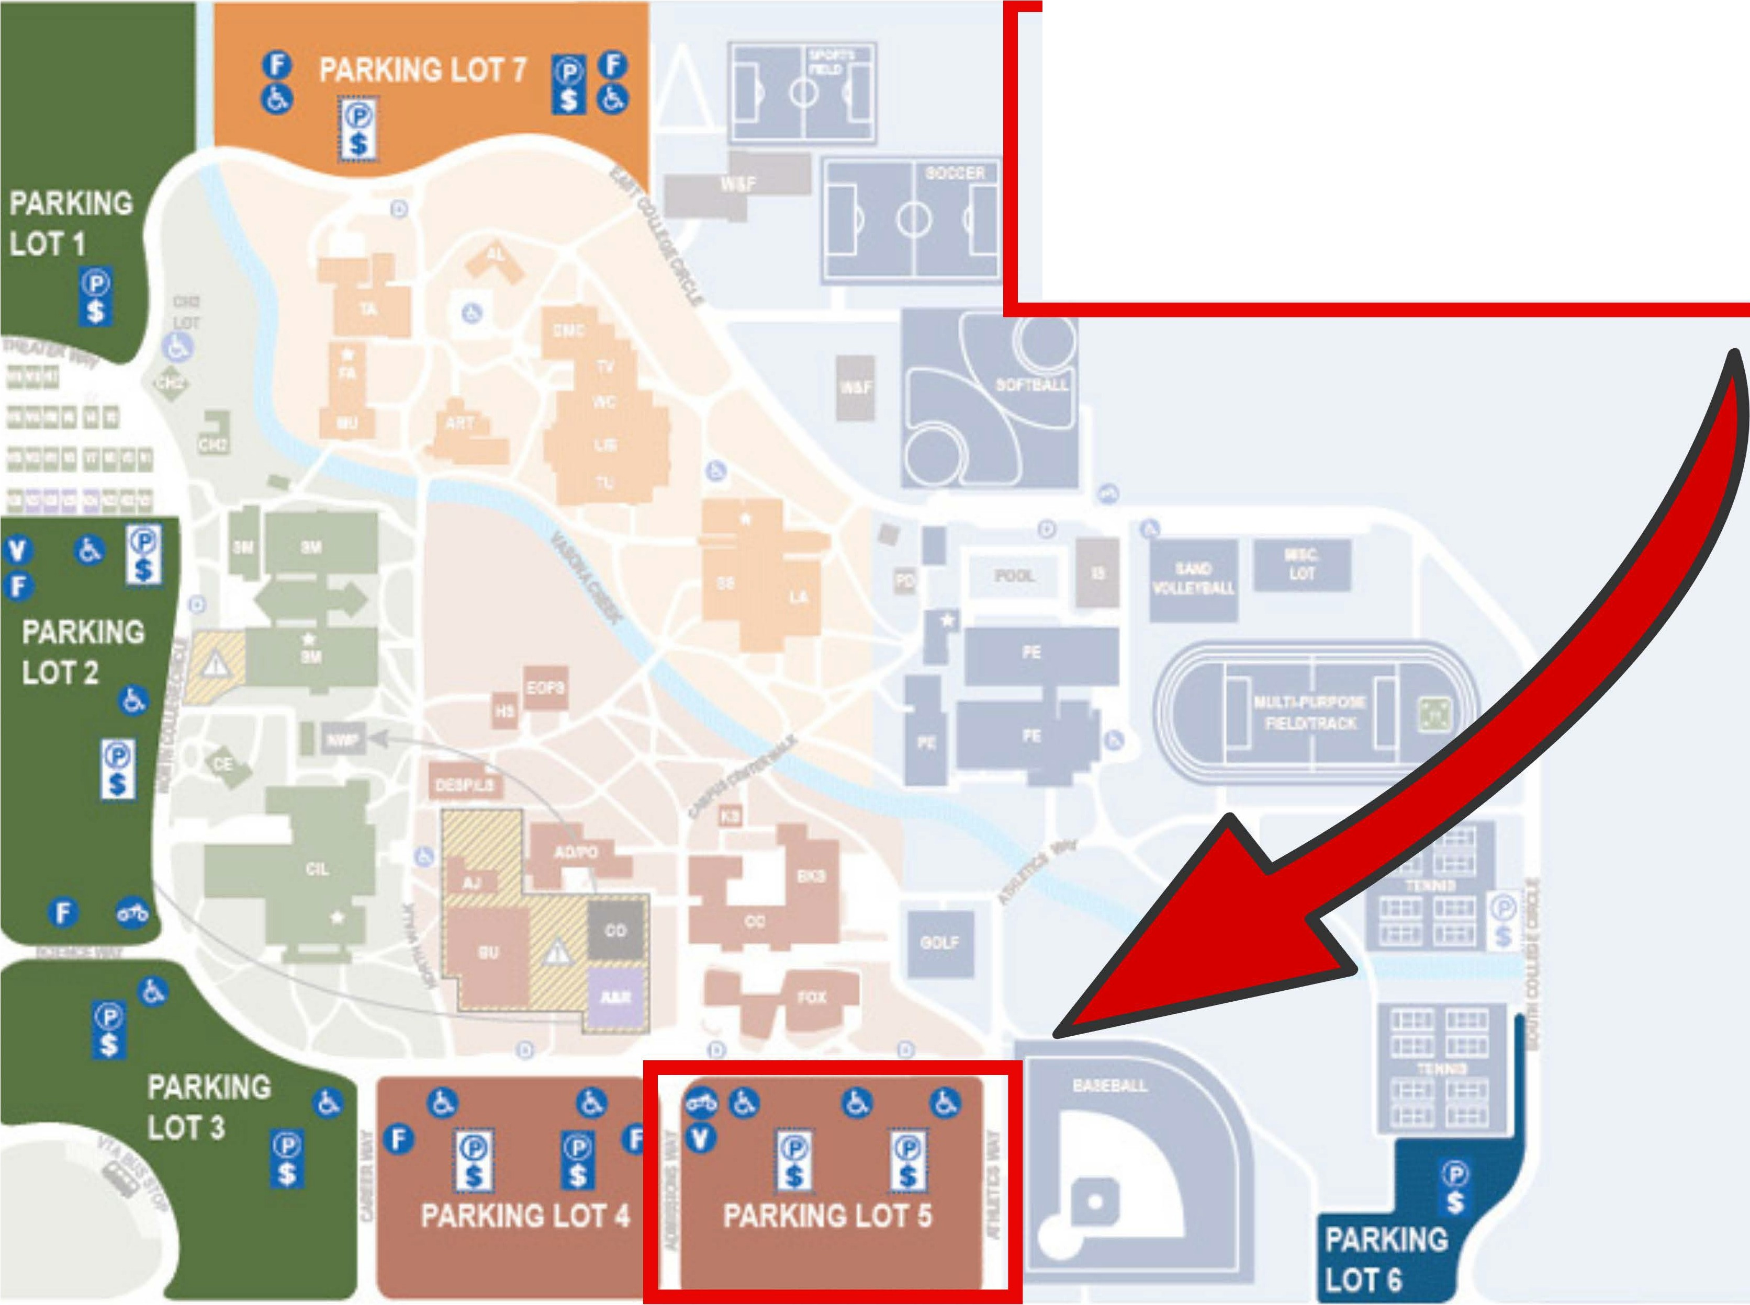

Fr u t vale Avenue

